Microstructure
Magnification | As Sprayed | HIP 850 | HIP 1200
5kX  As Sprayed does not have 5kx for the top layer microstructure |  | 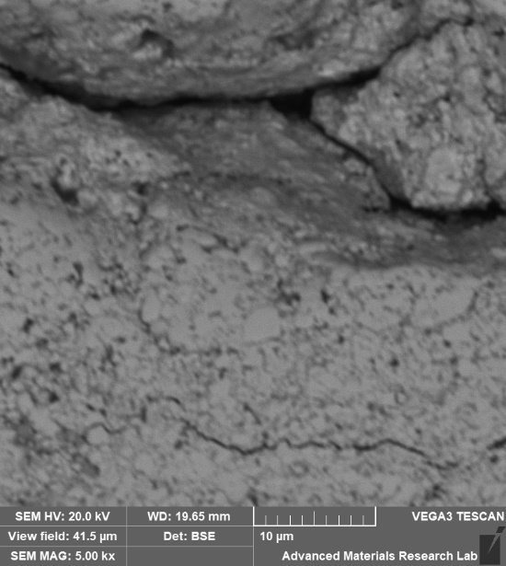 | TBD
10k X  HIP 850 10kX microstructure is very blurry. Might need to be redone. | 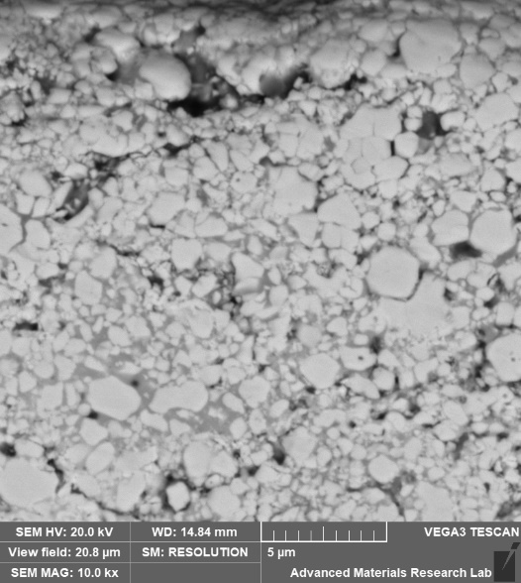 | 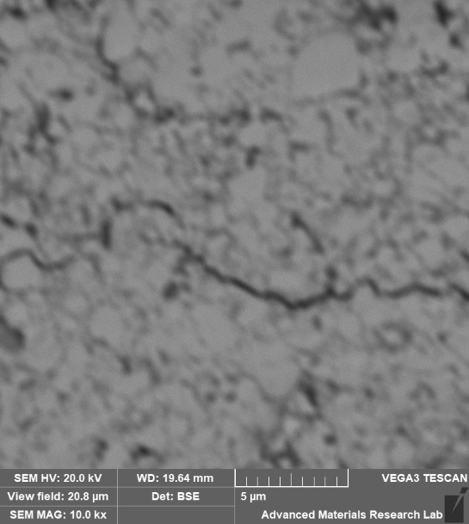 | TBD

