 | As Sprayed | HIP 850 | HIP 1200
15 X  Top View – As Sprayed is missing SE of 15X.  10X shows the entire crater.  SE of 1200 is too dark, BSE is alright.  Would suggest avoiding use in publication, as it might not be worth the effort? | 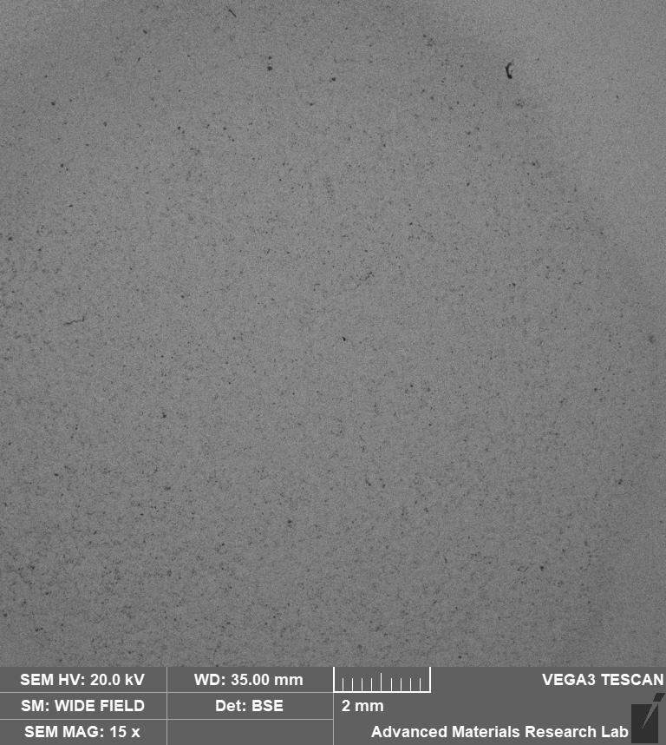 | 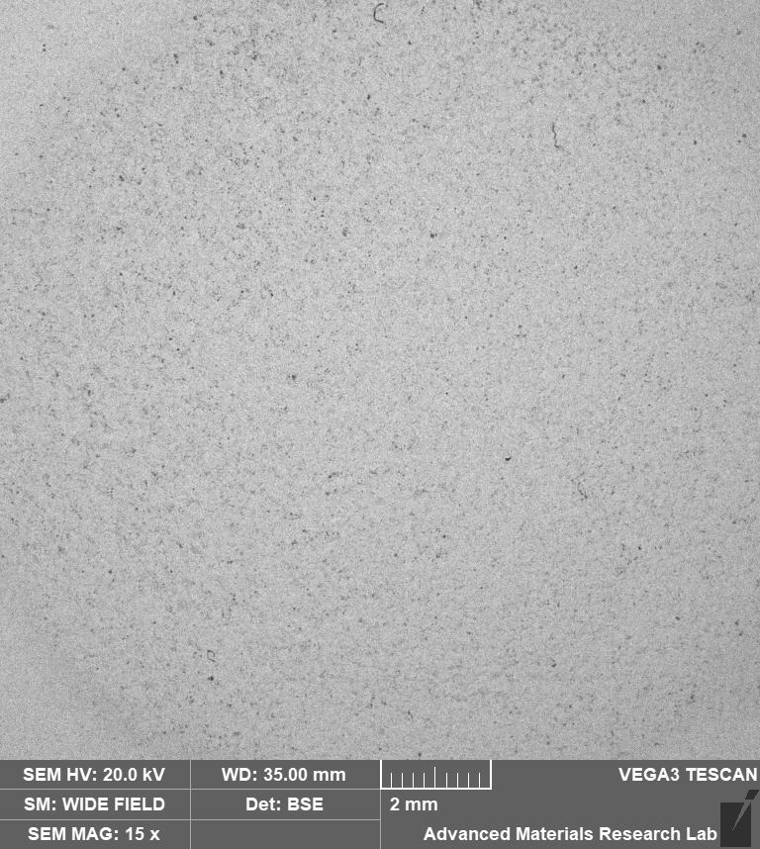 | 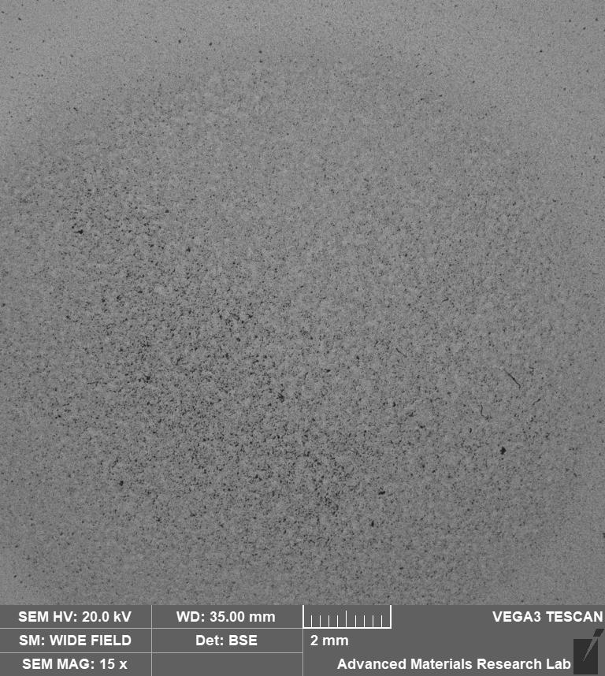
 | - | 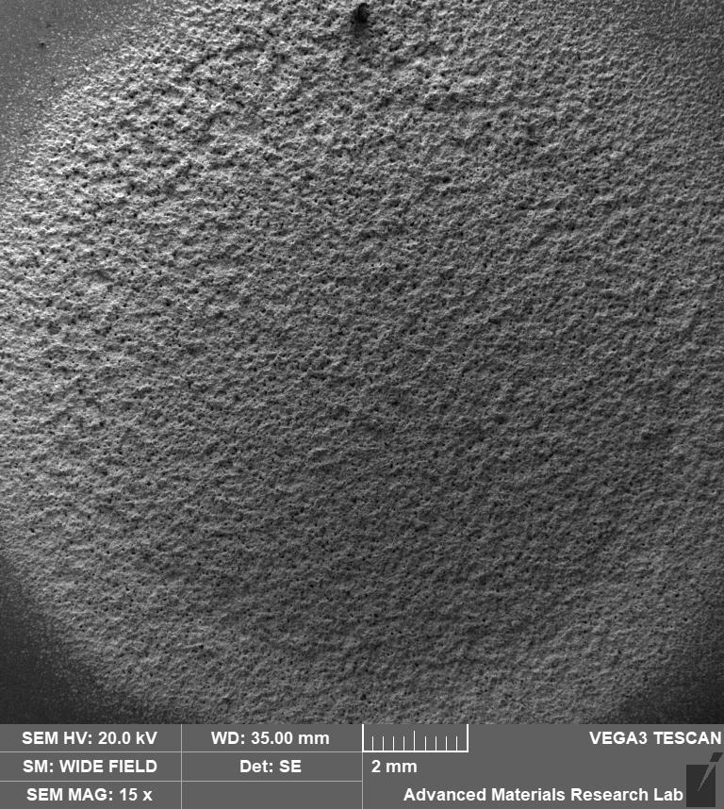 | 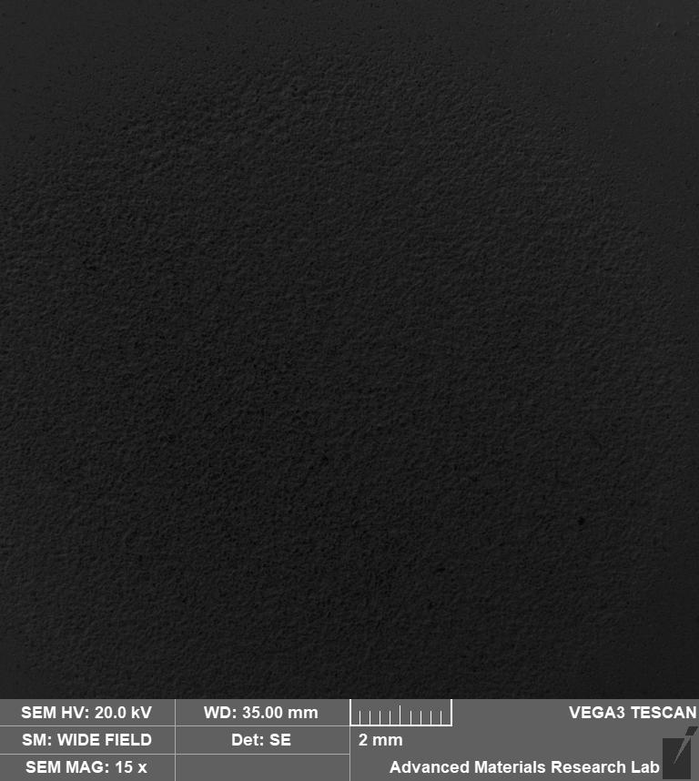

Cavitation Crater – 150X
 | As Sprayed | HIP 850 | HIP 1200
Cavitation Center – 150X  SE | 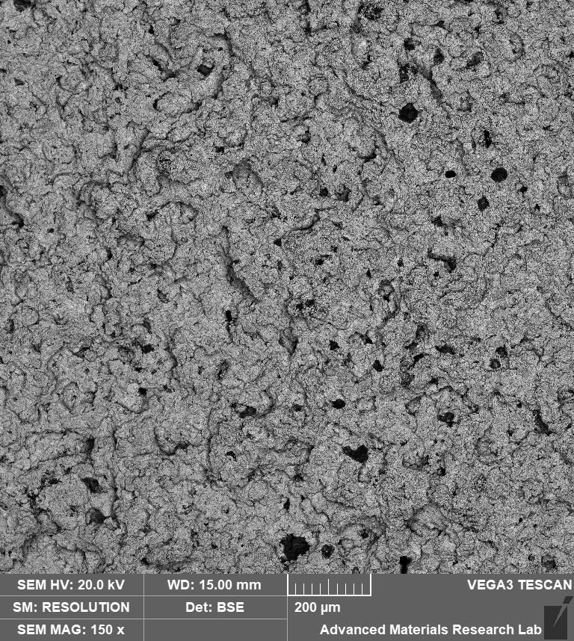 | 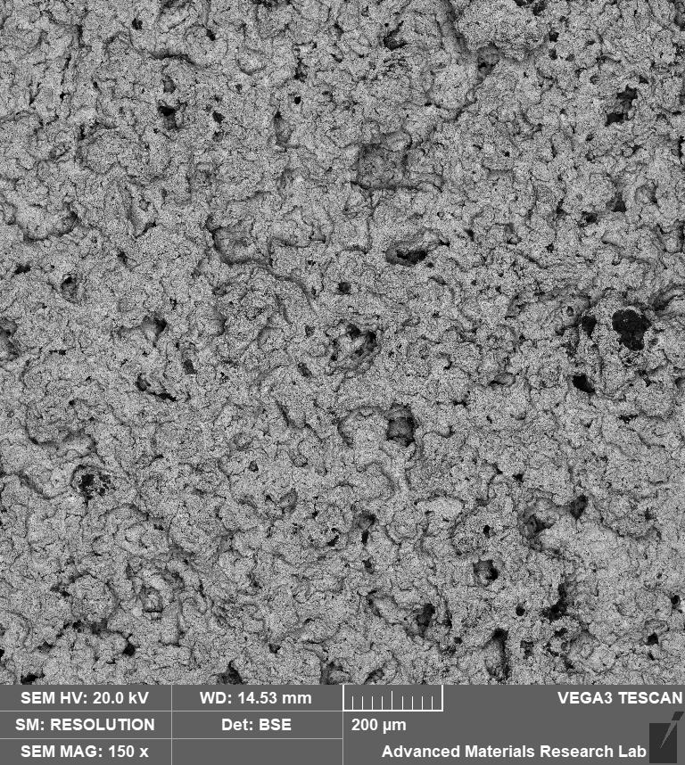 | 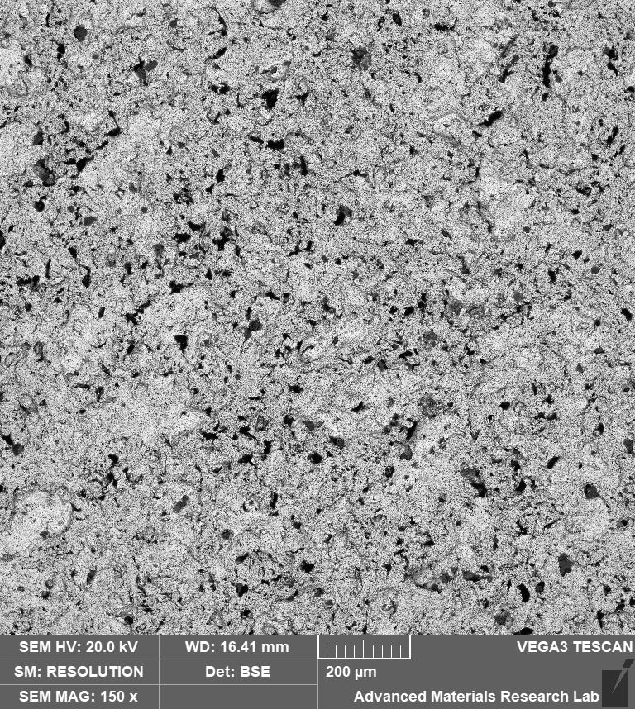
Cavitation Center – 150X  SE  The different shades are not great, I must admit. Does distract from the features. Must try and figure out how to maintain the same brightness (or how to do post-processing) | 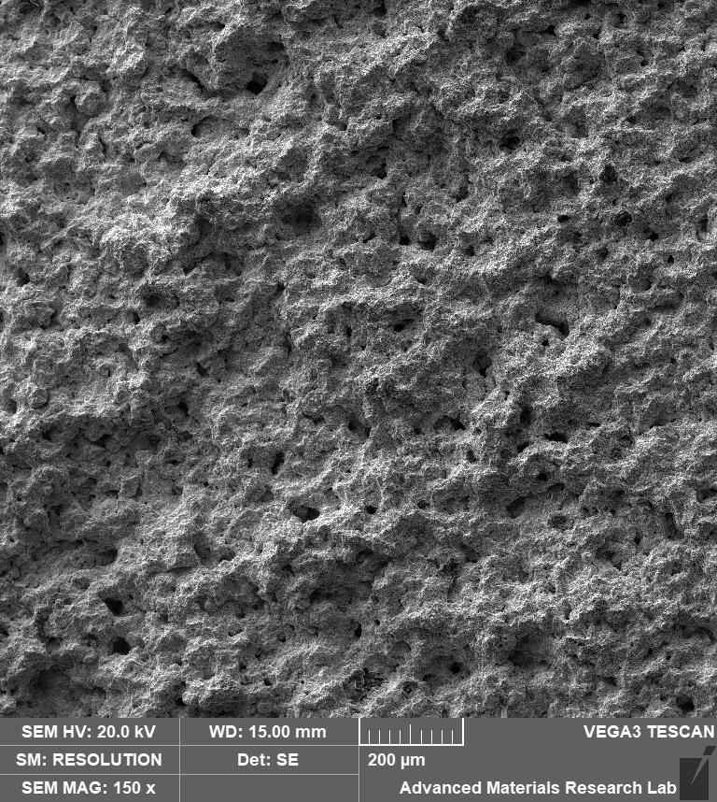 | 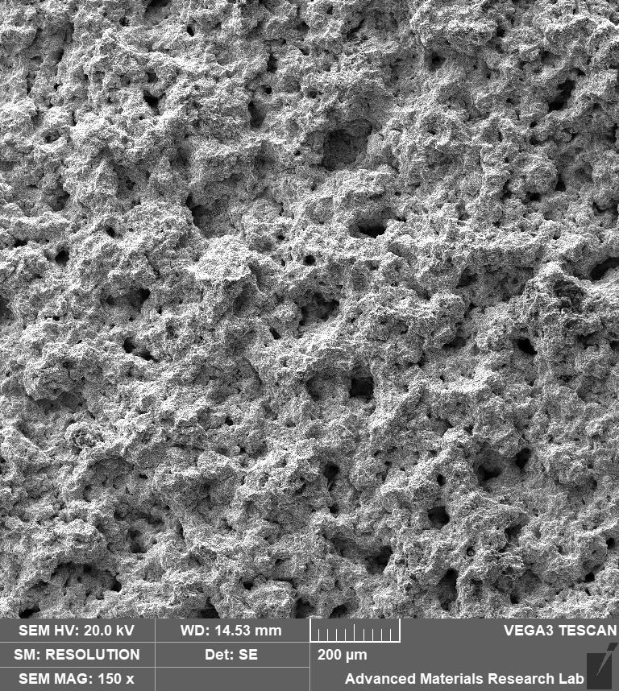 | 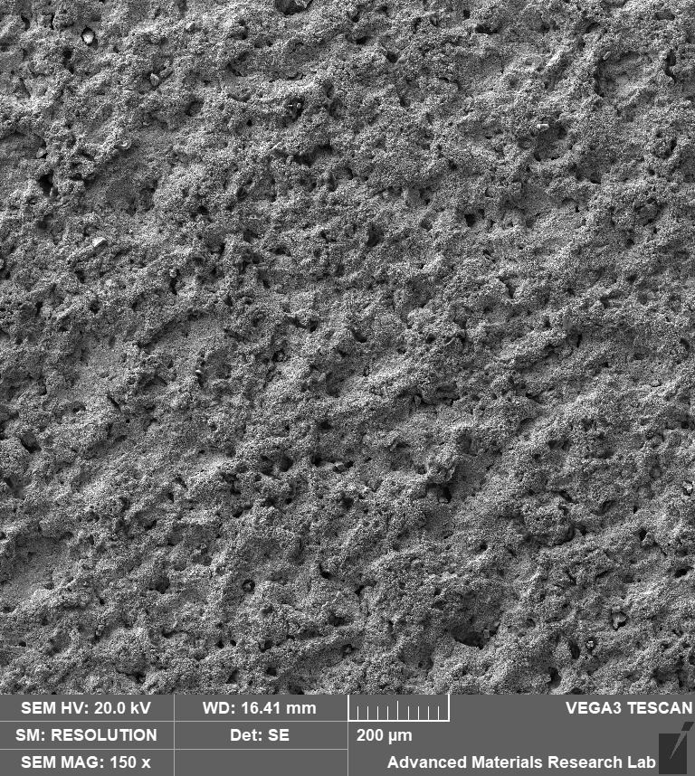

Cavitation Crater – 500X
 | As Sprayed | HIP 850 | HIP 1200
Cavitation Center – 500X  SE | 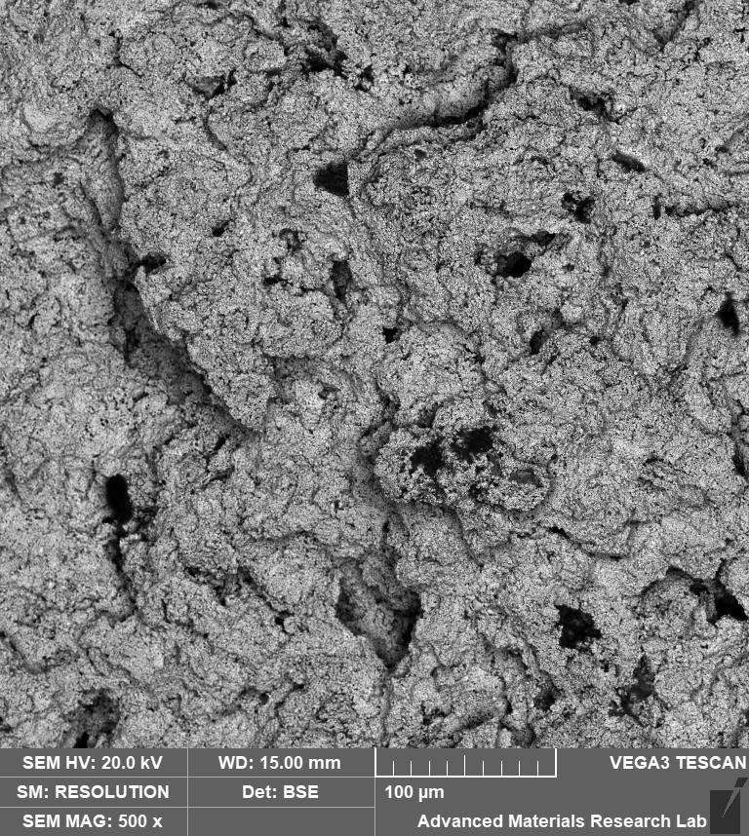 | 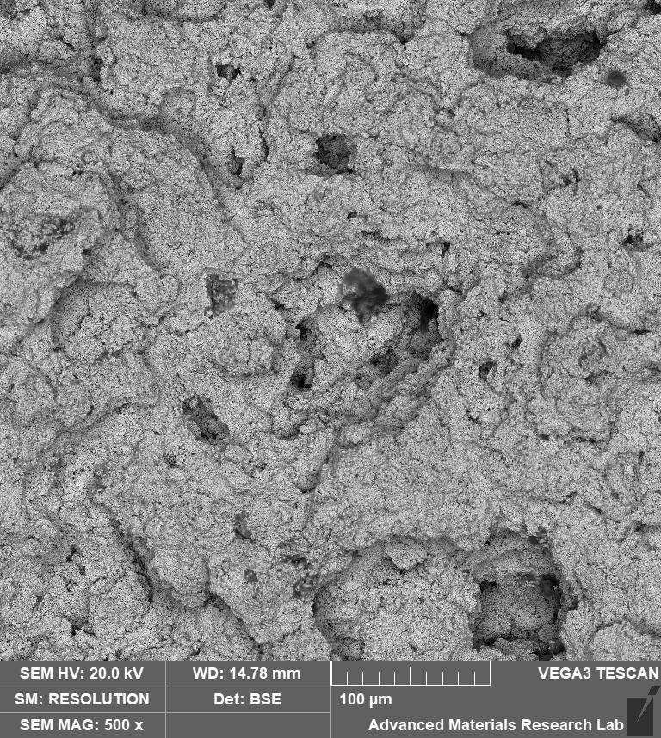 | 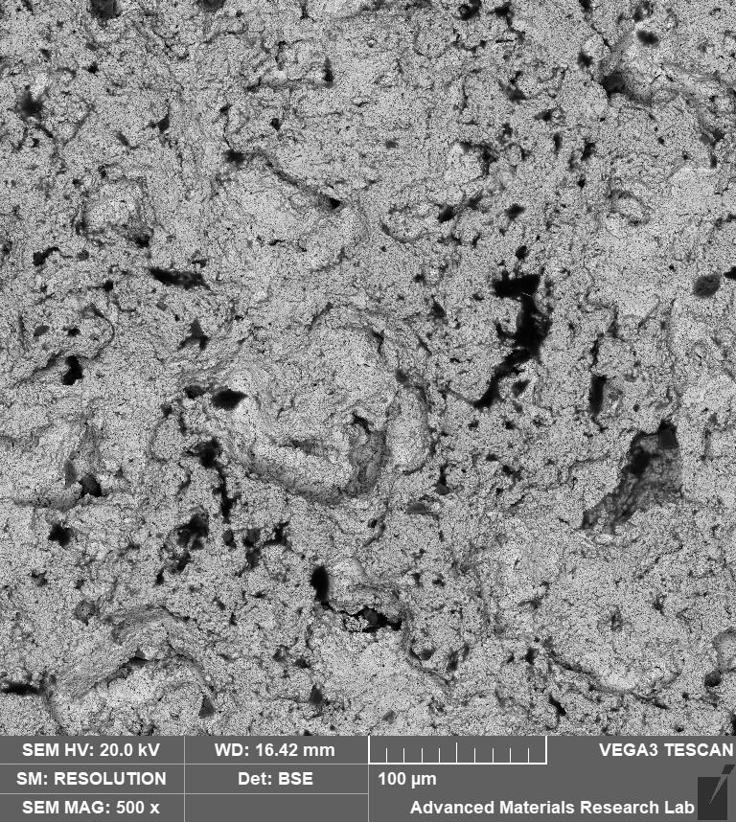
Cavitation Center – 500X  SE  The different shades are not great, I must admit. Does distract from the features. Must try and figure out how to maintain the same brightness (or how to do post-processing) | 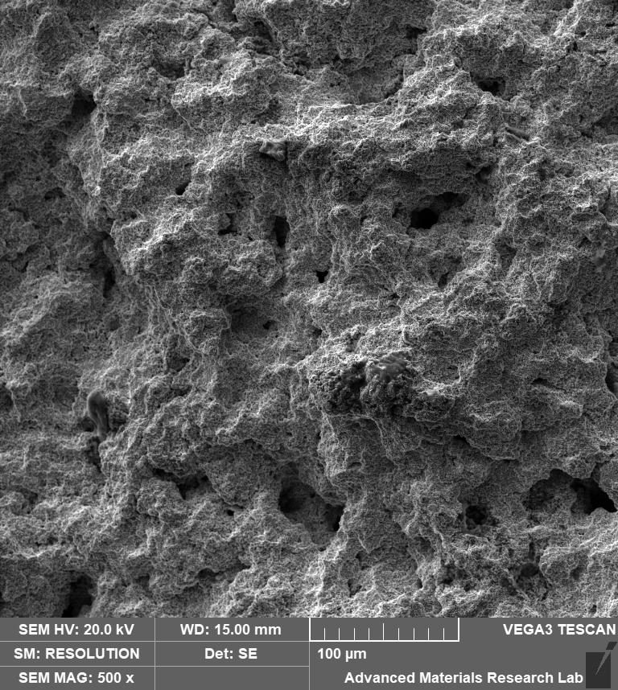 | 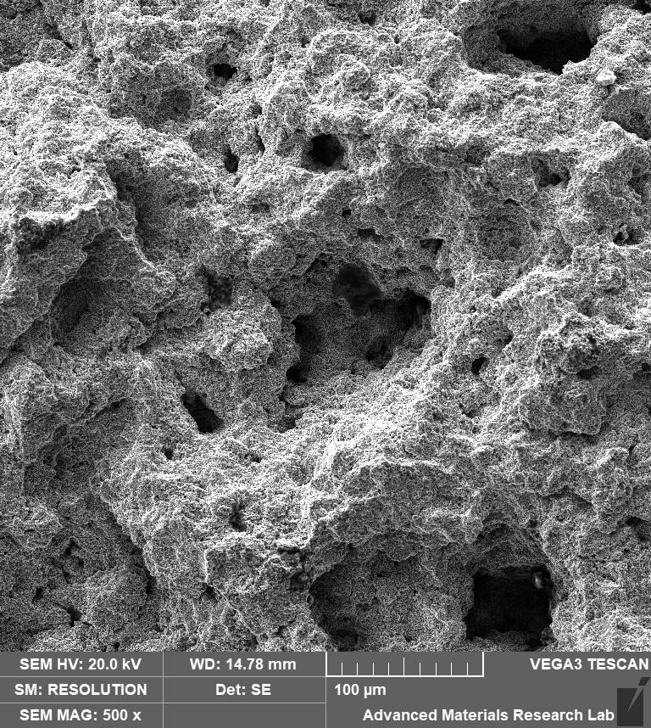 | 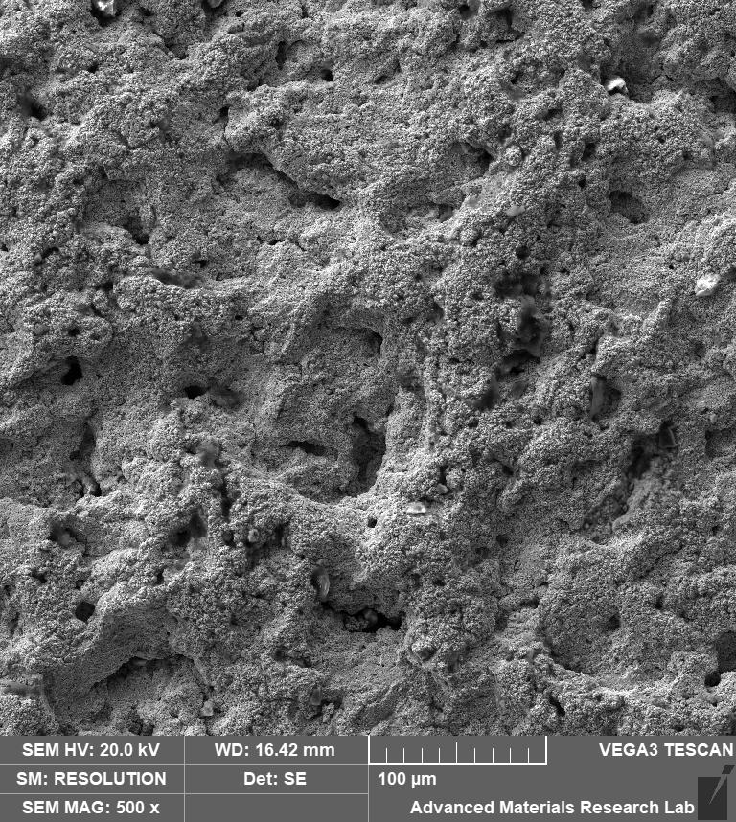

Cavitation Crater – 1000X
 | As Sprayed | HIP 850 | HIP 1200
Cavitation Center – 1000X  SE | 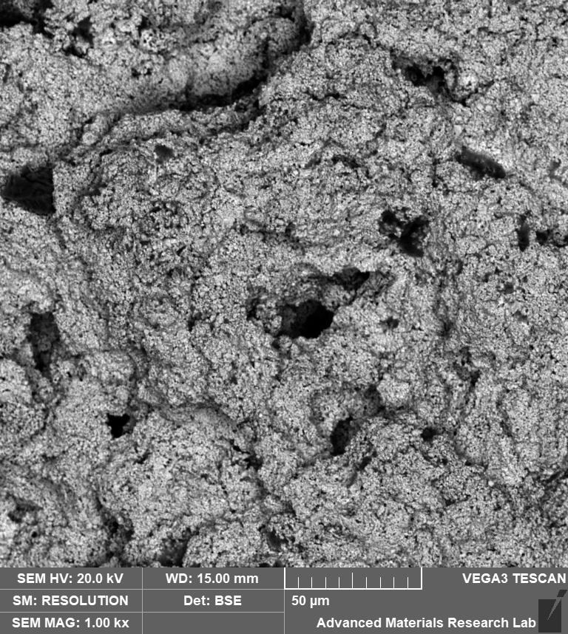 | 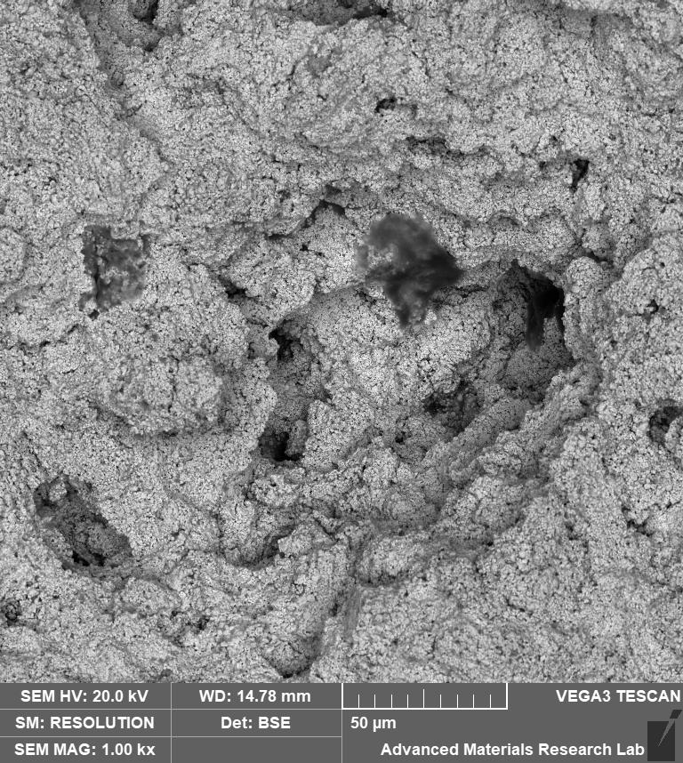 | 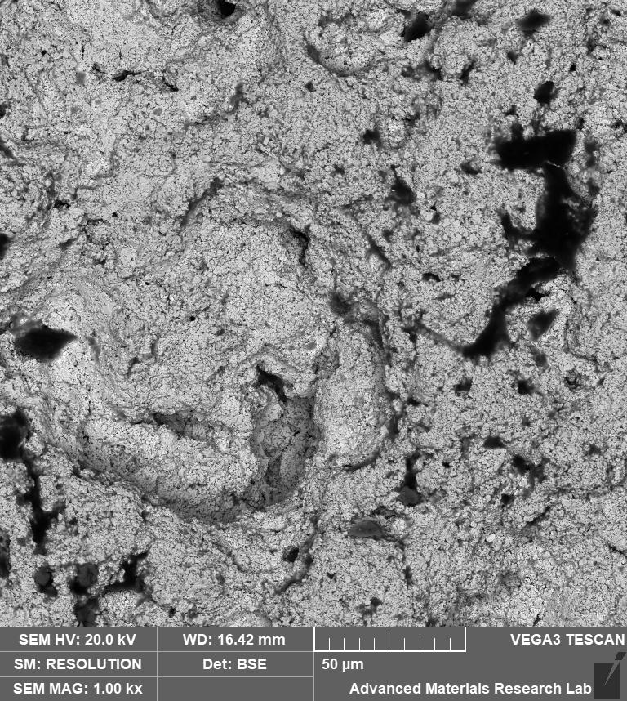
Cavitation Center – 1000X  SE  The different shades are not great, I must admit. Does distract from the features. Must try and figure out how to maintain the same brightness (or how to do post-processing) | 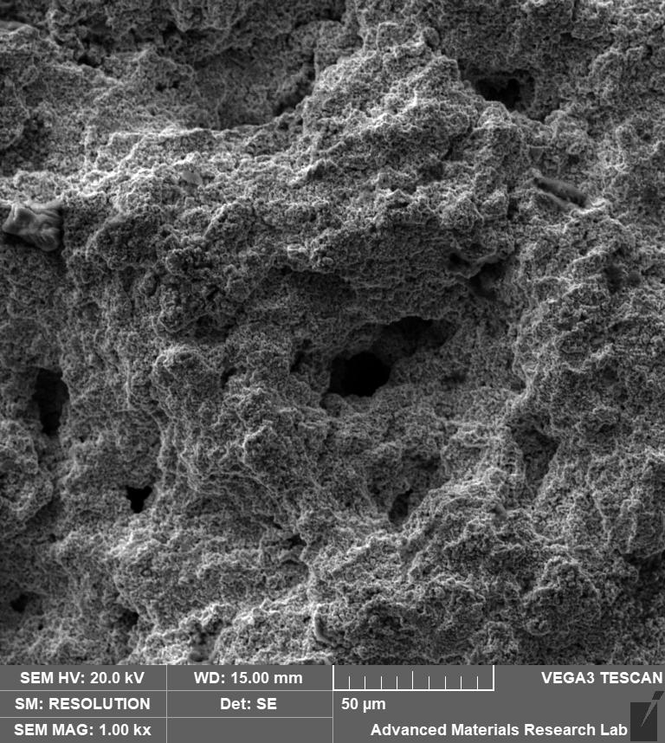 | 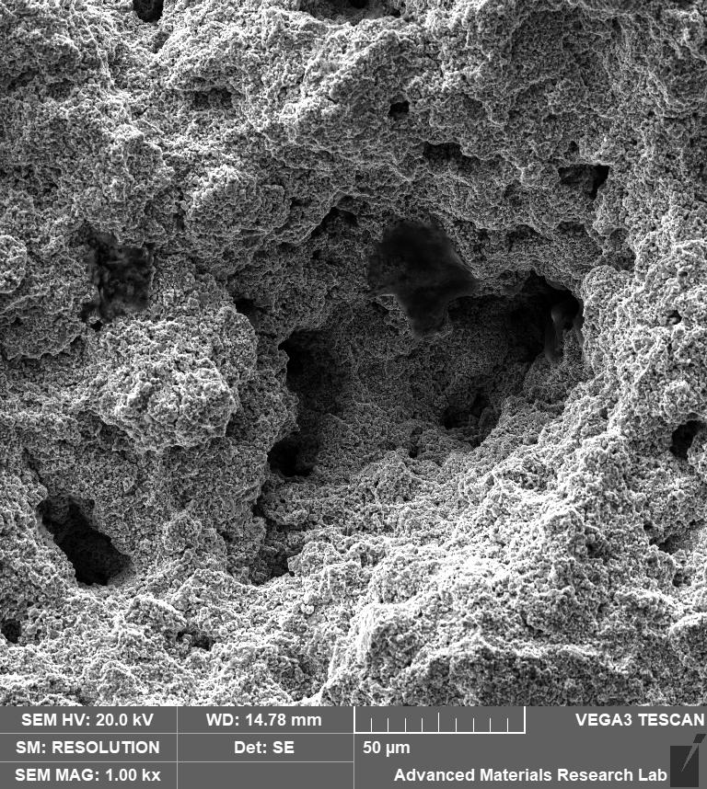 | 