Layer Overview
Magnification | As Sprayed | HIP 850 | HIP 1200
250X  Description:  Overview of Coating  As Sprayed 250X has issue regarding lack of top layer. To be redone using Samples 3 & 4 | - | 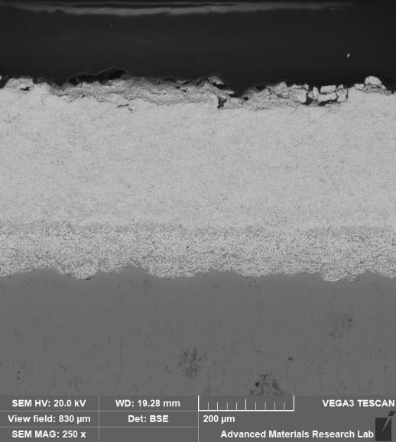 | TBD
500X  Description:  Overview of Coating  As Sprayed 500X has issue regarding lack of top layer. To be redone using Samples 3 & 4 | 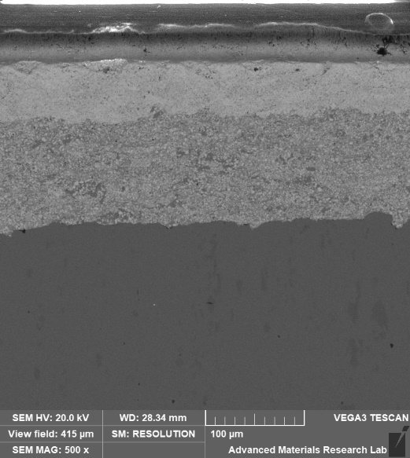 | 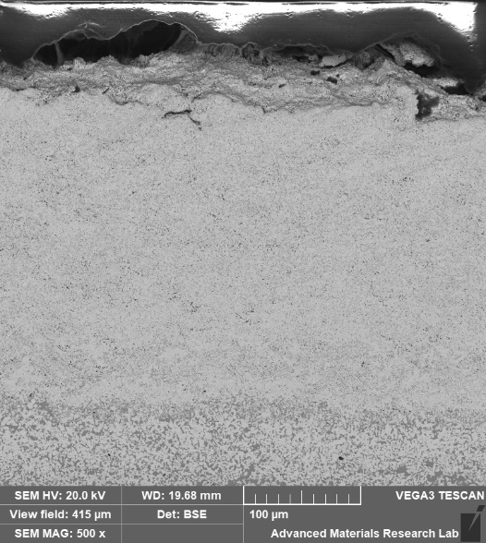 | TBD
1000X - HIP850 coating is not visible at 1000X, and is barely visible at 500X. Would recommend 250X for all

